Managing Interfaces in the Specific Architecture
Purpose: This guideline outlines how Interfaces are worked with, curated, classified, stored, and maintained within the Specific Architecture (SpA) model in Enterprise Architect (EA). Interfaces form a traceable knowledge base and serve as sources for modelled Requirements, Information Objects and Specifications.
Audience: SpA maintenance team.
Version | Author | Note
1.0 | Petr Bureš | Revised, simplified structure of the Interface, added requirements, Information object and Specification connection.
1.1 | Petr Bures | Reworked from NAP reference architecture specifics to a Generic Specific Architecture

Scope
This guideline covers:
- Content of the Interface and how it is linked to the other SpA objects

Role of Interface in the SpA
Definition: a point where two systems, subjects, organizations, etc. meet and interact.
In FRAME the interfaces connections to the Architecture and its content are not specified.
In the SpA the interface is a central point of the communications view, attached to the physical data flow, connecting two components of the system (subsystems or modules). The intention of the Interface is to describe the use of the interface, classify it, analyse its connection and safety requirements, to identify (connect) relevant requirements, specifications and information objects.

Modelling Interfaces in the SpA

Naming Convention
Interface names follow this format:
- A meaningful name focusing on the main interface purpose

Interface Content
Each Interface object must include:
- Identification – abbreviation and long name of the interface, usually by referring to objects connected via the interface.
- Type – Clearly classify the specification into one of the defined types (User Interface, Programming Interface or Hardware Interface)
- Description –a paragraph or more of description of the interface + how the interface is used in the context of the ITS Service.
- Related documents – Information about additional documents further specifying the Interface, full name of the document where in the interface specified and a hyperlink to the text.
- Communication requirements (per functional data flow)
  - data type: what type of data are being transmitted
  - size of message [B]: the maximum expected size of the message
  - maximum delay [s]: the acceptable latency of the message (urgency)
  - message interval [s]: how often message needs to be transmitted
  - security level [-]: what is the needed security level for the transmitting

Interface type
- User Interface (UI): The space where interactions between humans and machines occur. This includes graphical elements like buttons, icons, and menus in software applications.
- Programming Interface: In software development, an interface defines a set of methods or functions that a class or system must implement, enabling different software components to interact.
- Hardware Interface: The physical and logical connections between different hardware components, such as USB ports or network interfaces.

Communications Requirements
Communication requirements are briefly specified in the early FRAME, they have not been used and since then the IT situation has changed dramatically, so only some parts will be reused.
An Analysis of the Physical Data Flows to identify the characteristics of the physical links that will carry the data, to allow safe and secure sizing of the connection:
- What is the type of data? Generating:
  - Required Bandwidth: how often data is updated, how quickly they have to be available, what is their maximal size, how many users are expected to access it at the same time
  - Required Security
Since this could be different per functional dataflow, this analysis is performed for each functional dataflow of the physical dataflow. Resulting information is the maximum of each analysed functional dataflow.
NOTE: Sometimes even the functional dataflow is too generic and needs to be broken down into parts that have different needs.
Item | Values | note
Type of Data | Static, Dynamic, Semi-static | Ideally provide a brief overview of the data
Message size | Bits, Kb, Mb | Specifies the size of data items in bits, kilobits, or megabits. This is an estimation based on the experience with respective type of data
Latency | Seconds, minutes, hours, days, months | The allowable delay from when data is generated to when it is utilized. Based on the urgency, potential pre-actuality of the data and type of data. For highly dynamic data like incident, accidents or status information (travel times) is this value rather low, while for some static data updates it could be days
Interval | on occurrence, seconds, minutes, hours, months, years | Specifies the frequency with which the data items are generated. The message generation is periodical or in expected.
Security | None, Low, Medium, High | None: Public information with no security requirements.  Low: Data that requires protection against unauthorized changes and identification before use.  Medium: ???  High: Data that needs to be protected against unauthorized reading, often using encryption

Communications Requirements example
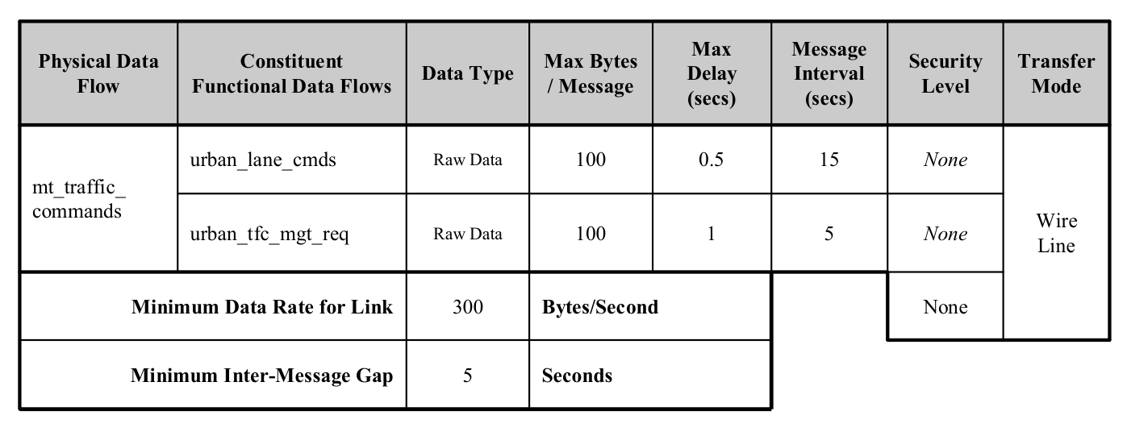
Figure 1 Example of Communication Requirements

Connecting Interface to other SpA objects
The Interface is specified by its description, communication requirements, physical data flow – triplet (subsystem/module – data flow – subsystem/module) and by:
- Recommendations linked to the Interface: Specifications linked directly are not mandatory, they serve as a good example
- Requirement(s) linked to the Interface: Specifications linked to the Interface via requirements yield mandatory requirements (either form the law or by decision of the NAPCORE)
- Information Object(s) linked to the Interface: if there is specific information object known (described, e.g. per legislative requirement) it can be linked to the Interface.
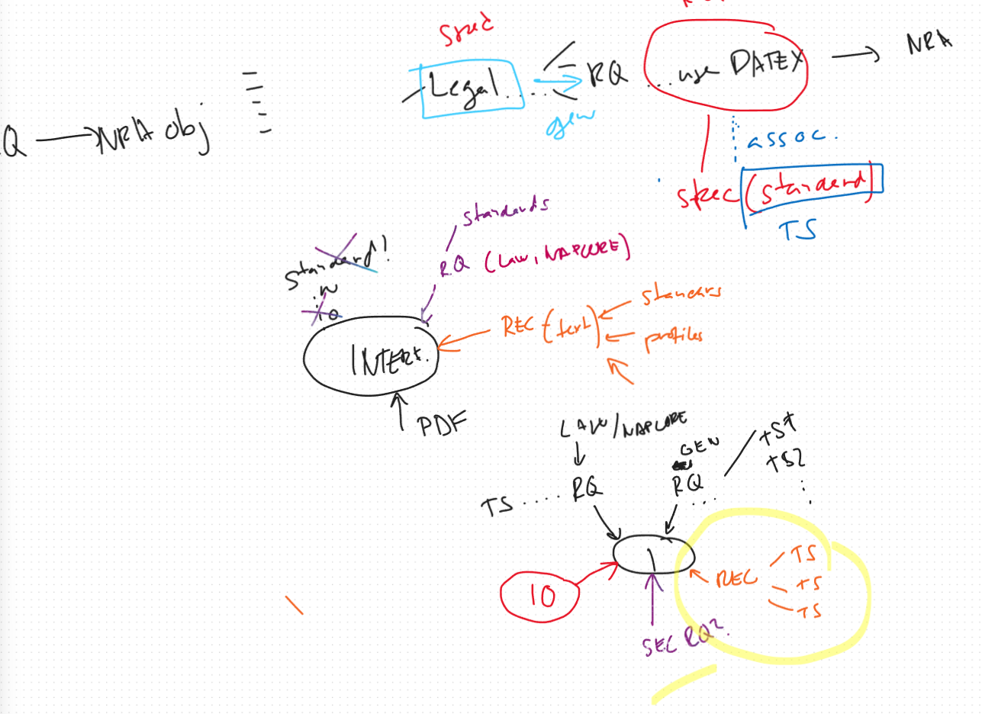

Open questions
- Could the physical rata flow be linked with more interfaces? E.g. different types?

Data are available before the situation occurs (e.g. planed roadworks, new road, etc.)

